# **SAN Server Configuration using iSCSI Protocol**

**On Server Side**

* **For this Configuration Lab, you will be requiring total 2 HDDs, one will behave as a driver for iSCSI controller & other one would be used as block device on client side. I will be using /dev/sda & /dev/sdb for this lab.**

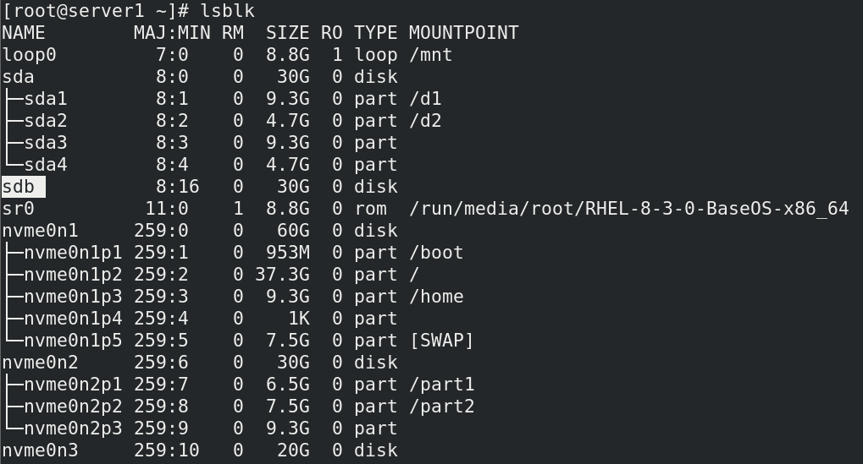

* **Assign a MSDOS style Partition table to the HDD (/dev/sdb) & start creating partitions into it. This Block Device will be shared in the network.**

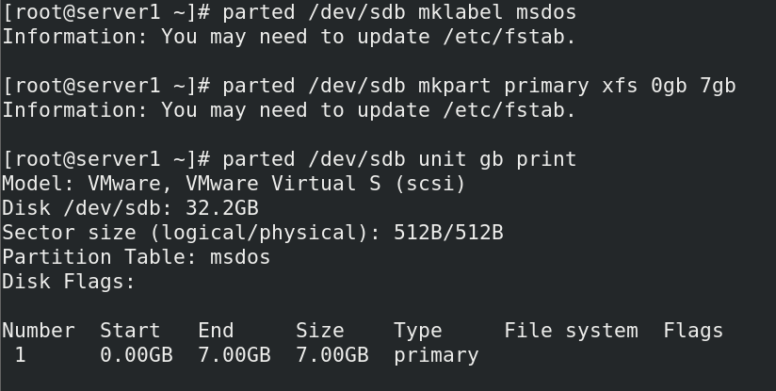

* **For Configuration of SAN Server, you require a package called targetcli, check if it installed on your system or not. If not present, install it.**

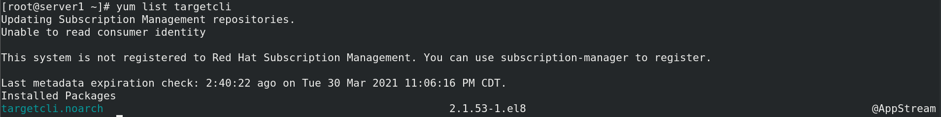

* **Enable the Service called target.service, in order to start the configuration for SAN server**



* **Enter inside the Tagetcli utility in order to configure SAN server.**

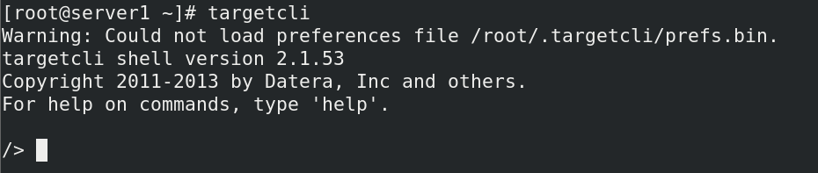

* **List all the different directories inside targetcli utility**

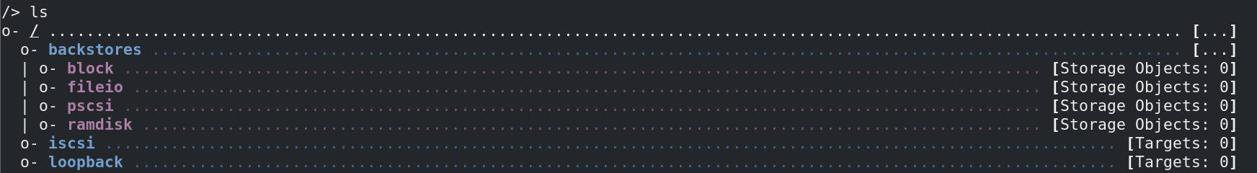

* **Here we have converted our partition (/dev/sdb1) into virtual block storage device.**

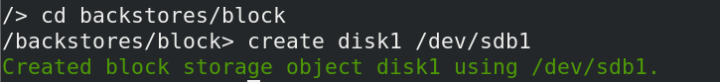

* **Here we have created a driver for our iSCSI Controller & its Image is saved at /root/driver.img which has size of 100MB (this size is more than enough for the driver img)**

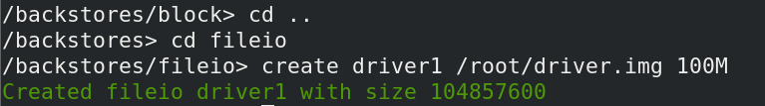

* **Verify Block Device & Driver that is been created.**

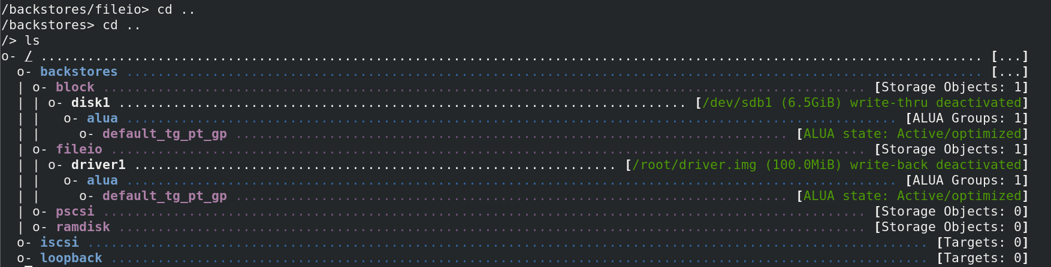

* **In this step we are creating a Target inside the Target Server (SAN Server) & assign an IQN (iSCSI Qualified Name) to this target.**

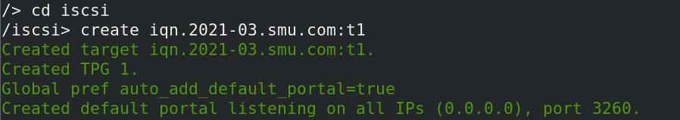

* **Verify if the target is Created Perfectly using the ls command.**

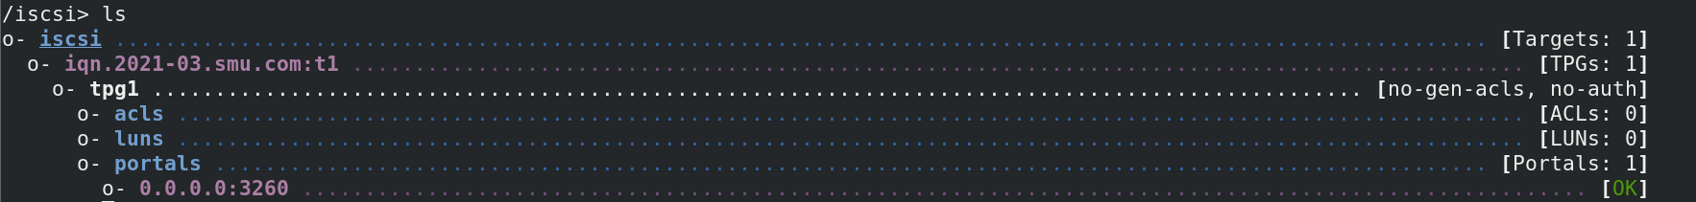

* **Now delete the Default Network Portal since it is not our IP address here we are mapping the created IQN with Server’s IP address.**

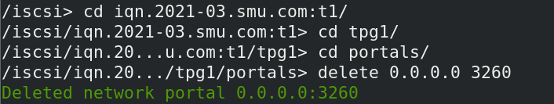

* **Create a new network portal for our own IP address**



* **Now Create Logical Unit Numbers, inside each LUNs reside the Block device and the image driver.**

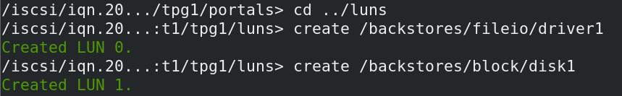

* **Configure Access Control Lists, & give access to iSCSI initiator IQN i.e. Client Machine. Remember when there is a SAN server in the network, the client & the server communicate using IQN (iSCSI Qualified Name)**

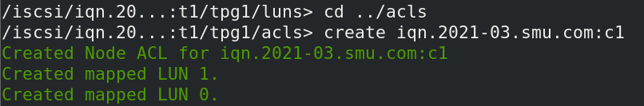

* **Verify if the ACLs are configured perfectly.**



* **Set the Authententication Parameters (userid & password) for iSCSI initiator IQN i.e. Client Machine.**

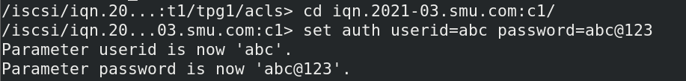

* **Verify if iscsi directory is configured perfectly.**

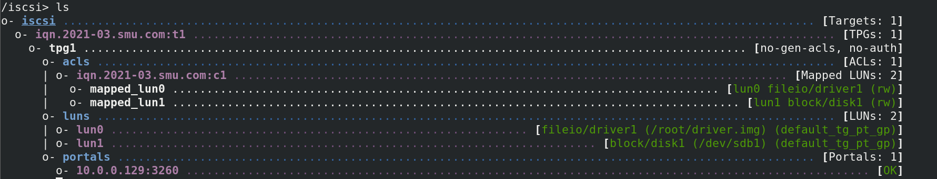

* **Verify if everything is configured perfectly onto SAN server i.e. iSCSI target**

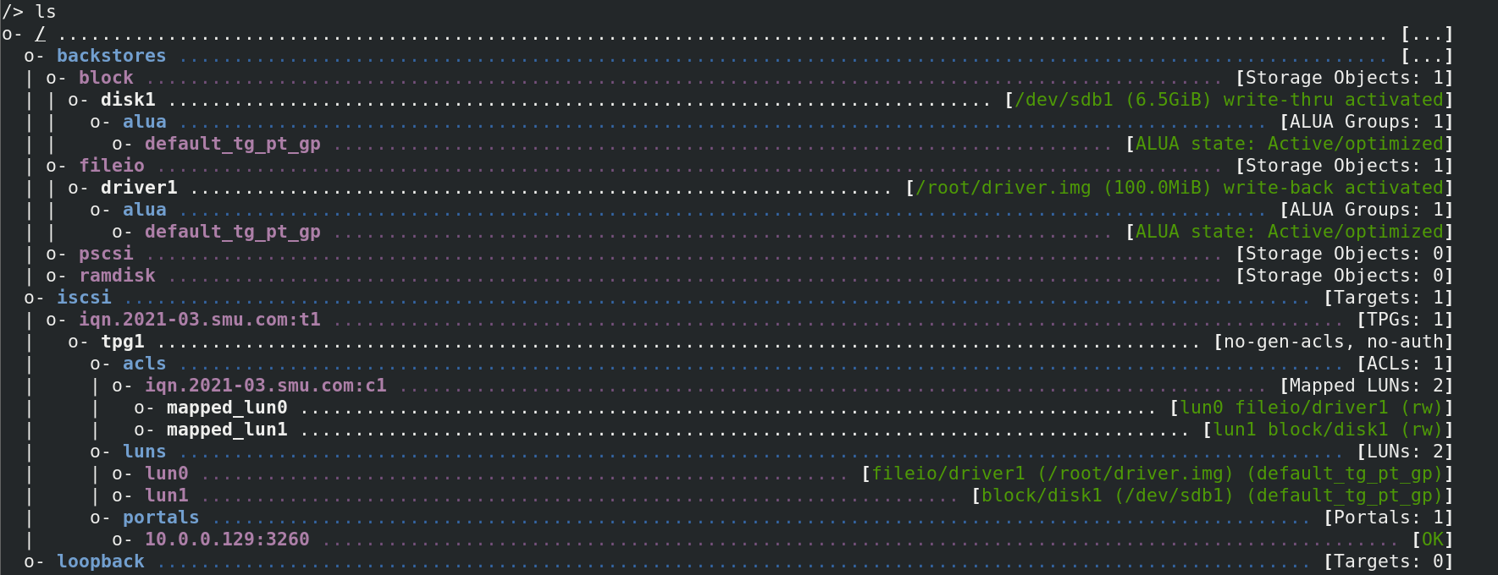

* **Exit from the targetcli interface**

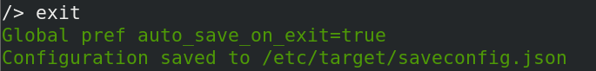

* **After the configuration is done restart the target service.**



* **Now disable the firewall service**



**On Client Side**

* **Make sure iscsi-initiator-utils package is present on the client machine if not then install it.**

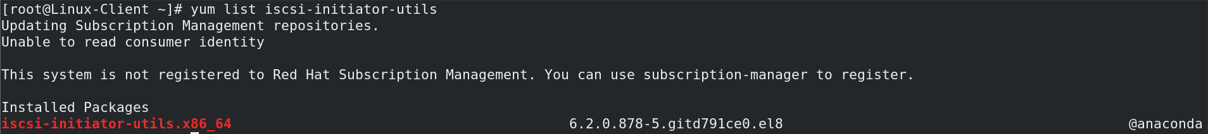

* **Enter the IQN for this iscsi initiator i.e. Client Machine, inside this file location below**



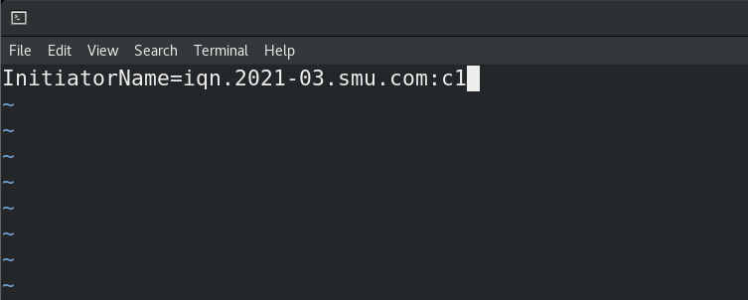

* **Using the below command you are letting the initiator know about the target (SAN Server)**



* **After executing the above command, a file will be created inside /var/lib/iscsi. Inside the file add the below lines (It means using this Authentication info. contact the iscsi target)**



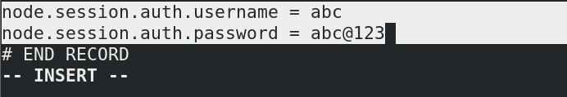

* **Restart the below 2 services after the following configurations has been done.**

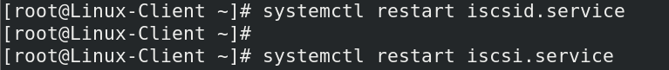

* **Verify using lsblk command that you can see the driver (/dev/sda) and the block device (/dev/sdb) on the Client Machine. This is the flexibility that we get from SAN server, we can configure the block device & start creating partitions based on our choice.**

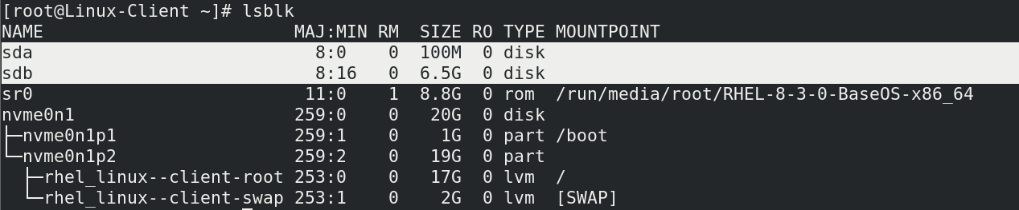

* **Assign the partition table to the block device & start creating partitions into it.**

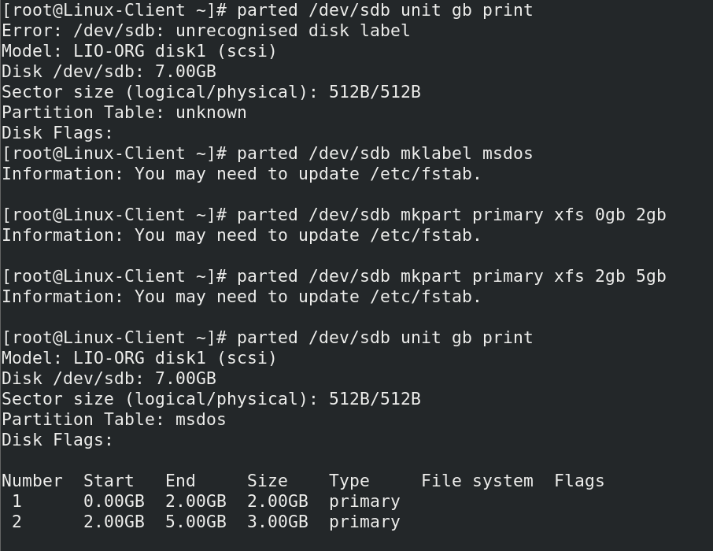

* **Format the partitions created in order to be in use for storage purpose.**

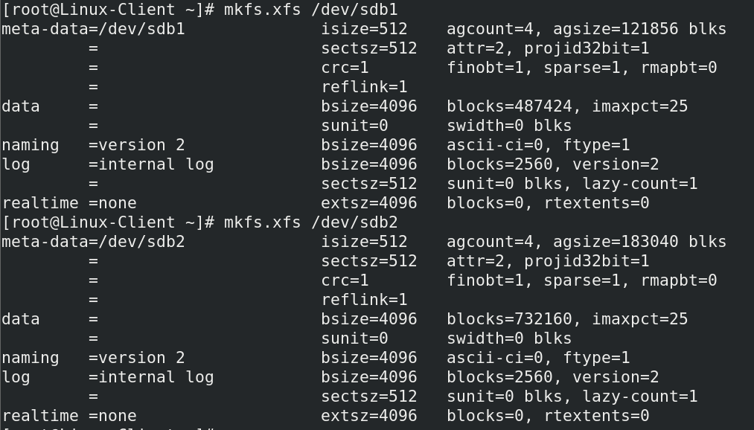

* **Create 2 empty directories in order to mount these disk partitions.**



* **Now mount the disk partitions on respective mount points.**



* **Create some data into the directory.**

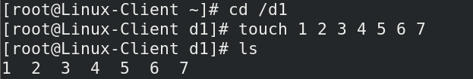

**You can see that using SAN Server, the block devices are shared in the network & on Client side these block devices can be used based on user’s choice.**